# LCD Display

An LCD (Liquid Crystal Display) is a flat-panel display technology that uses liquid crystals to display alphanumeric or graphical data. Commonly used in electronics is the 16x2 LCD, which shows 16 characters per line on 2 lines.

**Working Principle:**  
LCDs work by blocking light using liquid crystals. They don’t emit light themselves but use a backlight. Electrical signals alter the orientation of the liquid crystals, which control the passage of light to display characters.

**Types**:  
- Character LCD (e.g., 16x2, 20x4)  
- Graphical LCD  
- TFT LCD  
- OLED (advanced type)

**Applications**:   
- Embedded systems  
- Calculators  
- Digital meters and clocks  
- DIY electronics projects

**Advantages**:  
- Low power consumption  
- Lightweight  
- Widely available

**Disadvantages**:  
- Limited viewing angle (in standard models)  
- Needs a contrast adjustment (via potentiometer)

### **Features of LCD16x2 :**

* The operating voltage of this LCD is 4.7V-5.3V
* It includes two rows where each row can produce 16-characters.
* The utilization of current is 1mA with no backlight
* Every character can be built with a 5×8 pixel box
* The alphanumeric LCDs alphabets & numbers
* Is display can work on two modes like 4-bit & 8-bit
* These are obtainable in Blue & Green Backlight
* It displays a few custom generated characters

### **LCD 16×2 Pin Diagram:**

* 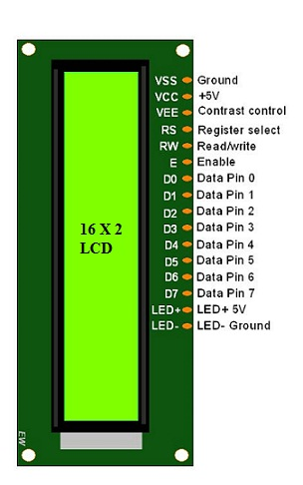Pin1 (Ground/Source Pin): This is a GND pin of display, used to connect the GND terminal of the microcontroller unit or power source.
* Pin2 (VCC/Source Pin): This is the voltage supply pin of the display, used to connect the supply pin of the power source.
* Pin3 (V0/VEE/Control Pin): This pin regulates the difference of the display, used to connect a changeable POT that can supply 0 to 5V.
* Pin4 (Register Select/Control Pin): This pin toggles among command or data register, used to connect a microcontroller unit pin and obtains either 0 or 1(0 = data mode, and 1 = command mode).
* Pin5 (Read/Write/Control Pin): This pin toggles the display among the read or writes operation, and it is connected to a microcontroller unit pin to get either 0 or 1 (0 = Write Operation, and 1 = Read Operation).
* Pin 6 (Enable/Control Pin): This pin should be held high to execute Read/Write process, and it is connected to the microcontroller unit & constantly held high.
* Pins 7-14 (Data Pins): These pins are used to send data to the display. These pins are connected in two-wire modes like 4-wire mode and 8-wire mode. In 4-wire mode, only four pins are connected to the microcontroller unit like 0 to 3, whereas in 8-wire mode, 8-pins are connected to microcontroller unit like 0 to 7.
* Pin15 (+ve pin of the LED): This pin is connected to +5V
* Pin 16 (-ve pin of the LED): This pin is connected to GND.